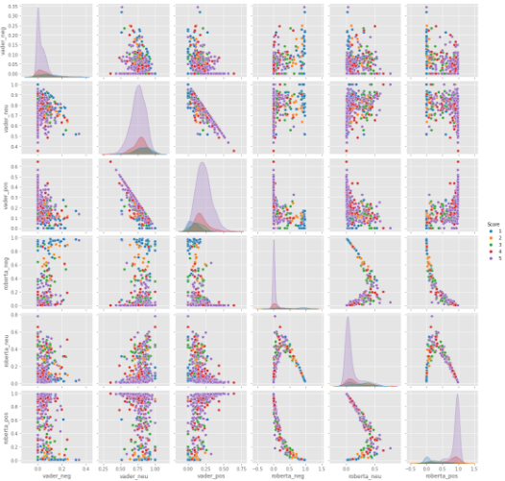

**Positive 1-Star and Negative 5-Star Reviews**

Lets look at some examples where the model scoring(by the commentator) and review score(by Roberta model) differ the most.

In [27]:

results_df.query('Score == 1') \

.sort_values('roberta_pos', ascending=False)['Text'].values[0]

Out[27]:

'I felt energized within five minutes, but it lasted for about 45 minutes. I paid $3.99 for this drink. I could have just drunk a cup of coffee and saved my money.'

In [28]:

results_df.query('Score == 1') \

.sort_values('vader_pos', ascending=False)['Text'].values[0]

Out[28]:

'So we cancelled the order. It was cancelled without any problem. That is a positive note...'

In [29]:

*# nevative sentiment 5-Star view*

In [30]:

results_df.query('Score == 5') \

.sort_values('roberta_neg', ascending=False)['Text'].values[0]

Out[30]:

'this was sooooo deliscious but too bad i ate em too fast and gained 2 pds! my fault'

In [31]:

linkcode

results_df.query('Score == 5') \

.sort_values('vader_neg', ascending=False)['Text'].values[0]

Out[31]:

'this was sooooo deliscious but too bad i ate em too fast and gained 2 pds! my fault'

RoberTa is a State-of-the-art model for sentiment analysis with high accuracy. But these are some nuanced comments which confused our model.